Software Requirements Specification

for

My Doctor,

Disease Diagnosing Mobile System

Version 1.0 approved

Prepared by

|  |
| --- |
| GROUP: CSC-03 |
| NAME | REG.NO | STUDENT NO. |
| Omara Micheal |  |  |
| Matovu joseph |  |  |
| Balintuma Isaac |  |  |
| Teberyowa Justine |  |  |

Makerere University

27th/November/2017

Table of Contents

Table of Contents ii

Revision History ii

1. Introduction 1

1.1 Purpose 1

1.2 Document Conventions 1

1.3 Intended Audience and Reading Suggestions 1

1.4 Product Scope 1

1.5 References 2

2. Overall Description 3

2.1 Product Perspective 3

2.2 Product Functions 3

2.3 User Classes and Characteristics 4

2.4 Operating Environment 4

2.5 Design and Implementation Constraints 4

2.6 User Documentation 4

2.7 Assumptions and Dependencies 5

3. External Interface Requirements 6

3.1 User Interfaces 6

3.2 Hardware Interfaces. 7

3.3 Software Interfaces. 7

3.4 Communications Interfaces 7

4. System Features 8

4.1 Disease Diagnosis. 8

4.2 Disease Ranking. 8

4.3 Self-Medication. 9

4.4 Medical Report Generation 9

4.5 Medical consultation 9

5. Other Nonfunctional Requirements 11

5.1 Performance Requirements 11

5.2 Safety Requirements 11

5.3 Security Requirements 12

5.4 Software Quality Attributes 12

5.5 Business Rules 12

6. Other Requirements 13

Appendix A: Glossary 14

Appendix B: Analysis Models 15

Appendix C: To Be Determined List 16

Revision History

|  |  |  |  |
| --- | --- | --- | --- |
| **Name** | **Date** | **Reason For Changes** | **Version** |
|  |  |  |  |
|  |  |  |  |

# Introduction

## Purpose

The purpose of this document is to provide a detailed description of the functionalities of My Doctor, Disease Diagnosing Mobile System. This document will cover each of the system’s intended features, as well as narrating the requirements of the software. The document also covers other technical dependencies that are related to the system.

## Document Conventions

This document contains some terminologies which readers may be unfamiliar with. The Appendix A (Glossary) section accounts for a list of these used terms and their definitions.

The times new roman font style accompanied by a font size of 12 is followed for most of the content in the document. Sections are bolded with an increase in font size to 18 while sub-sections are written with a font size of 14.

## Intended Audience and Reading Suggestions

This SRS document is intended for all individuals interested in self-medication as well as disease diagnosing. Readers interested in a brief overview of the system should focus the Introduction part as well as the overall description part of the document, which provides a brief overview of each aspect of the system as a whole.

Developers and project managers who wish to explore the features of My doctor, disease diagnosing mobile system in more detail should read on to Part 4 (System Features), which expands upon the information laid out in the main overview. The External Interface Requirements part in section 3 offers further technical details, including information on the user interface as well as the hardware and software platforms on which the application will run.

Readers interested in the non-technical aspects of the project should read Part 5, which covers performance, safety, security, and various other attributes that will be important to users.

Additional information which does not fit logically into the other sections is mentioned in section 6 to elaborate more on the components of the system.

## Product Scope

My Doctor, Disease Diagnosing Mobile System will be comprised of mainly two important components a client-side mobile application which will run on Android handsets, and a server-side application which will support and interact with various client-side features. The system will be designed to facilitate the process searching an inserted sign / symptom and ranking it to a most suitable disease possessing the inserted sign or symptom. A clear description is shown Appendix B section where a use-case diagram reflects the actual disease diagnosing process.

## References

Abbreviations. (2017). *Abbreviations.com*. Retrieved from Abbreviations.com: http://www.abbreviations.com/

*Android – Android phones*. (2017). Retrieved from Android: https://www.android.com/phones/

Compare, S. (2017). *Android versions comparison | Comparison tables - SocialCompare*. Retrieved from Socialcompare.com: http://socialcompare.com/en/comparison/android-versions-comparison

Intel. (2017). *Minimum System Requirements for Android* 4.2 and 4.4*. Retrieved from Intel: https://www.intel.com/content/www/us/en/support/articles/000006179/education/intel-education-software.html

Link, S. (2017). *Semantic Analysis of Functional and Non-Functional Requirements in Software Requirements Specifications*. Retrieved from https://link.springer.com/chapter/10.1007/978-3-642-30353-1_42

Wikipedia. (2017). *Medical diagnosis*. Retrieved from En.wikipedia.org: https://en.wikipedia.org/wiki/Medical_diagnosis

wikipedia. (2017). *Self-medication*. Retrieved from En.wikipedia.org: https://en.wikipedia.org/wiki/Self-medication

# Overall Description

This section provides a high level description of the entire application. It describes the product perspective, product functions, user classes and characteristics, operating environment, design and implementation constraints, user documentation, assumptions and dependencies.

## Product Perspective

This disease diagnosing system is a modified health-based system intended for use on the Android platform by all android devices. While the mobile application is the main focus of the project, there is also a server-side component which will be responsible for database and synchronization services inform of retrieving information to the client mobile device. The scope of the project encompasses both server- and client-side functionalities, so both aspects are covered in detail within this document.

The diagram below illustrates the interactions between the server and client applications of the system.

server

Android device 3

Android device 1

Android device 2

From the above illustration, different android devices send information to the server and feedback is provided respectively.

## Product Functions

The application is to enable the patient/user to enter his/her details like name, age, gender.

The application enables the user to insert any sign/symptom of a particular disease he/she is likely to be facing.

The system the searches the inserted sign / symptom to a respective disease in a database.

The system then identifies and ranks a suitable disease basing on the signs and symptoms inserted by the user.

It enables the user to view the resulting disease he/she is likely to be facing.

## User Classes and Characteristics

This project is meant to offer an online disease diagnosing solution that is faster, easier, and more convenient than manually estimating the likelihood disease. Consequently, the application will have little or no learning curve, and the user interface will be as intuitive as possible. Thus, technical expertise and Android experience should not be an issue. Instead, anticipated users can be defined by how they will use the product following the help menu that will be provided in the mobile application.

## Operating Environment

The main component of the system is the software application, which will be limited to the Android operating system (specifically Android 4.0 and above). The application is not resource-intensive, so there are no practical hardware constraints. The app will rely on several functionalities built into Android’s Application Programming Interface (API), so ensuring appropriate usage of the API will be a major concern. Beyond that, the application is a self-contained unit and will not rely on any other Android-related software components.

The application will, however, frequently interact with the server, which will be initially a free hosting server

## Design and Implementation Constraints

Programming will be done in java and xml. The phones having the application should be connected internet. The primary design constraint is the mobile platform. Since the application is designated for mobile handsets. Database support like MySQL is needed for server.

The following constraints have to be achieved in the mobile application:

1. User-friendly GUI form

2. Application should run on android devices of android version 4.0 and above.

3. Data transmitted to the server from the application must have security to prevent unauthorized access by anonymous users.

## User Documentation

The major goal of My doctor, disease diagnosing mobile system is to identify and rank a disease basing on the signs and symptoms inserted by a user. Consequently, the application will be designed to be as simple to use as possible. Nonetheless, users may still require some supplementary information about each component of the system. The application will contain the Help menu, a feature explaining topics covering each of the application’s menus, features, etc. At any time, the user can navigate to the Help menu and select any of these topics to obtain more information. Details about the Help menu will be concise and precise as well as easy to understand.

## Assumptions and Dependencies

**HARDWARE DEPENDENCIES**

Some of the additional features rely on hardware components present in Android handsets. For

Instance, the android input key board will be used to insert text by the user. Consequently, this feature is entirely reliant upon the ability to android device functionalities. In addition, the application will use the handset’s screen to enable the user observe the right information he/she is feeding into the application. Both the key board screen functionalities will be assumed to be running in a normal state of the android device.

# External Interface Requirements

## User Interfaces

The My Doctor Application will provide users with various usability interfaces that will ease their interaction with the Disease Diagnosing System. Among these will include:

The Walk-through introduction interfaces which shall be displayed to the user during the first time usage of the application to enable him/her understand the usage, functionality and services provided by the application.

The Home interface which will provide a grid-like view of buttons indicating the various services provided by the application. The buttons will be composed of the activity/service icon together with the service name below it. These will include; The Diagnosis Button, Consultation Button, Records Button, and so on.

The Diagnosis Activity interface which will first require the user add in his critical details like sex, age range that will be required during the diagnosis process. These user details entered shall be saved to ease the diagnosis process during the user’s next time of using the application.

The input interface of entering the signs and symptoms shall provide a suggestion list of the signs and symptoms basing on the key characters entered by the user to save users time.

The Diagnosis Result Activity interface shall provide an ordered ranked list of possible diseases starting with the highly expected disease to the least expected one basing on the inserted signs and symptoms. The diseases shall indicate a clickable action to direct the user to a particular disease activity being selected proving all the possible signs and symptoms, medical recommendations and descriptions about the disease. For critical disease results that require immediate medical attention, an alert dialog shall be displayed to the user instructing him/her to seek immediate checkup from the hospital for confirmation. The user shall have to click the finish button after viewing the disease results to take him/her to the home activity interface or the back button to return to the disease list.

The saved records Interface shall provide a 4-digit Activity lock pin to secure the users diagnosed results as private.

The Consultation Activity Interface shall provide a list of Signed consultant doctors and nurses from the different hospitals and clinics in the various places of the country. On clicking the consultant of someone’s choice, the user shall be directed to the single consultant activity interface were he/she can fill in the required information which shall be sent to the consultant inform of a text appointment. Or press the call button to directly talk to the consultant.

All the Application Activity interfaces will have the same underlying style, with a carefully constructed color scheme and the layouts shall be fitting on all Android screen sizes.

## Hardware Interfaces.

In terms of hardware interfaces, the Disease Diagnosing system shall be able to function on all the versions of the Android platform since the My Doctor application that will be interacting with the system will only be supported on Android Devices.

The Application will require internet connection for interaction with the External database server and synchronizing of data. Information will be sent to the server using the TCP/IP protocol.

The application will also be extended to others services like Call and SMS services.

## Software Interfaces.

The mobile application of the system is to be developed using the Android Studio IDE that bases on the android operating System using java JDK and Android SDK tools.

The Application is to work with the MySQL database server during the diagnosis process and the SQLite application database for storage of the diagnosed results.

## Communications Interfaces

The user will be able to interact with the Disease Diagnosing System through the My Doctor Application which will require internet connection to fetch and receive data from the MySQL database server.

Data will be transferred through the TCP/IP protocol.

The application will also use the SMS protocol for sending consultation appointment requests to the various doctors and nurses.

# System Features

This section provides the major services and functional requirements of the My Doctor Disease Diagnosing System.

## Disease Diagnosis.

### Description and Priority

Disease Diagnosis is associated with determining which disease or condition that corresponds to a person's symptoms and signs. This feature is of high priority in the My Doctor Application.

### Stimulus/Response Sequences

With this system feature, the user is to first enter his/her person details like age, sex, former disease infection and name. This is to be done only once for every user of the application.

After, the user will have to continue to the next interface where he inserts in the various signs and symptoms he/she will be facing by typing into the fields appropriately. And as he does so, the system will provide automatically completed suggestions for signs and symptoms to enable the user pick a correct symptom as per the contents of the database.

When the user is through with providing the signs and symptoms, the system will use the search and ranking algorithm to identify the possible disease or diseases the user may be facing. It will then have to provide the result to the user inform of a ranked list in case the identified diseases are more than one.

### Functional Requirements

REQ-1: This feature will require internet connection to send and retrieve data to the database server.

## Disease Ranking.

### Description and Priority

Disease ranking is associated with scaling the various possible diseases basing on the degree of their occurrence. This feature will depend on the signs and symptoms that will be provided by the system user.

### Stimulus/Response sequences.

With this feature, the user will have to ensure that there is reliable internet connection for the system to work properly and fast. Without internet connection, the system will have to alert the user to connect to the internet.

After providing the ranked list of diseases, the system will have to provide a clickable indicator to each disease directing the user to view full details of each particular disease.

### Functional Requirements

REQ-1: Reliable internet connection will be required.

REQ-2: The ranking algorithm should be fast.

## Self-Medication.

### Description and Priority

Self-medication is associated with treatment of common health problems with medicines especially designed and labeled for use without medical supervision and approved as safe and effective for such use. This feature will enable the application user to do self-medication basing on the results provide after the diagnosis.

### Stimulus/Response sequences

The user will have to click on the provided disease or diseases which will take him/her to the single disease activity which will provide all the necessary recommendations and treatment Prescriptions.

### Functional Requirements

REQ-1: This feature will also require internet connections.

## Medical Report Generation

### Description and Priority

A medical report will be a document format file presenting the diagnosis results of the user. At the end of each diagnosis process, all the data involved will have to be documented, saved and stored in the local database of the application.

### Stimulus/Response sequences

At the end of every diagnosis, the user choses to either save the diagnosed results or not for confidential reasons.

### Functional Requirements

REQ-1: This feature will require an internal application database to store the user’s medical results.

## Medical consultation

### Description and Priority

This feature will be associated with interaction between the application users and the medical personnel for medical assistance, help or advice. This will be a low priority feature since the assurance of existence of medical consultants is not guaranteed.

### Stimulus/Response sequences

The application will provide a user interface interaction with signed medical consultants through call and sms mobile services.

### Functional Requirements

REQ-1: This feature will require SMS and Call functionalities of the mobile devices.

# Other Nonfunctional Requirements

## Performance Requirements

**Internet connectivity.**

The mobile application will require good internet connectivity so as to grant a user full access and usage of the system. This is because the ranking of the inserted signs / symptoms to a particular disease(s) requires internet connection to return best results at a better confidential interval. In addition to that, the retrieval of the identified disease from the server holding the database will need internet access so as correct results to return accurate results to a user using the application.

**Android version of 4.0 or above.**

The mobile application will require only those devices of android version 4.0 and above because the features and some functionalities in the application are to be supported by all devices running the mentioned android version. In addition to that, latest android devices run higher android versions like android 6 (Mash Marrow), android 7 (Nougat) and android 8 (Ore) and google support for devices running lower android versions might stop due to technological advancements and innovativeness of most developers aiming at developing applications that run on only android version 4 and above.

**Minimum RAM of 500MBs**.

This requirement is so vital as it aims at proper functioning of the phone`s applications successfully. Therefore, devices with RAM of 500MBs and above will be able to launch the developed application successfully and it functions properly irrespective whether other phone applications are running on the same devices. This requirement is to guide users owning devices with lower memory from freezing of their devices while using My Doctor, Disease Diagnosing Mobile System. This promotes safety usage of the application as well as maintaining the good service condition of the devices running the application.

## Safety Requirements

**Not suitable use on devices with low memory.**

The mobile application of the system is to run on almost all android based devices. Overuse of the application for a long period of time is likely to drain more RAM and this is likely to slow down the functioning of some devices with quiet low memory. Therefore, users are expected to run less applications at a meantime so that the potential of the android device is never affected.

**Auto save of the user’ information.**

User’s information returned by the system is to be saved automatically on his / her device while he /she is interacting with the application as well as connected to the internet. This is meant to provide full time access to information returned by the system even if the user’s device is in the offline state.

Therefore, the user’s device storage is likely to keep running low as he / she frequently uses the application in the long time period. The user is recommended to delete some of the database files that are stored on his device.

## Security Requirements

**Use of a PIN by a user to prevent anonymous users from accessing personal information.**

Since the system is categorized in the health department for maintaining the health of the citizens of the country, there is no method to authenticate the user’s identity while interacting with the application. However, a PIN security feature is to be used by a user on saving his data so as to prevent it from being viewed by anonymous users for purposes of personal security. Therefore, only the PIN encryption and security feature will be available in the system. In addition, in order not leak to unauthorized access on the server side therefore encryption measures like using the base 64 encoder will be embarked on each user’s information fetched from the mobile application to the database server. This implies that the information stored in the database will be stay under a high degree of encryption.

## Software Quality Attributes

**Easy usability of the mobile application**. The application will be more user friendly and interaction made by the user with the application will be made with ease so that more users adopt to using he application in addition to liking its functionality.

Full time access of the information. The system will be in position of saving users’ data which will make the user able to access his / her information even when the device is in the offline state. Therefore, there will be fulltime access of users’ information whenever they interact with the application.

**Portability of the application.** The mobile application is to consume less storage space while installed on the mobile device. This is because most data will be retrieved from a database hosted on a server. Therefore, less data will be stored on the android device thus maintaining the space complexity of the device.

**Reusability.** Users will be attracted to continue using the application for its functionality as to a good confidence interval, will always provide accurate results.

**Quick testability of the system.** Issues regarding testing of the mobile application will simply be made of the devices of android versions of 4 and above to verify the responsiveness of the mobile application on all the android platforms running on the devices.

**Correctness of the results returned.** To a good confidence interval, the system is to return accurate and correct results as the searching and disease ranking algorithms will be implemented to return the most suitable diseases basing on the many inserted signs and symptoms.

## Business Rules

My doctor, disease diagnosing mobile system grants full rights and access of the product functionalities to all users owning android devices and wish to use the mobile app. Sharing of the mobile app’s apk among different android devices is also accepted as it increases the number of users the disease diagnosing mobile system.

# Other Requirements

My Doctor, Disease Diagnosing Mobile System is also likely to have contacts section where a user will possibly interact with medical assistants and guiding counsellors at a free cost and calls will enable the progress of their interaction.

A database for storing inserted signs and symptoms in addition to their respective diseases calls for a server side implementation that holds information for the

User (patient), treatment, disease as well as all the associated relationships. The database will be implemented using MySQL. The following provides an example of information that may be stored in the

database:

* User: ID, name, gender, age, sign/symptom.
* treatment: treatmentType, date
* disease: ID, sign, symptom.

The server will be configured and through use of PHP, will allow interaction

and processing in conjunction with the database. Processes to be done on the server include:

pushing/pulling data, updating data, and generating notifications.

Appendix A: Glossary

|  |  |
| --- | --- |
| **Acronyms/Abbreviations** | **Meaning** |
| App | Application |
| Co | Company |
| e.g. | for example |
| etc. | and so on |
| ICT | Information and Information Management |
| IDE | Integrated Development Environment |
| i.e. | That is to say |
| IT | Information Technology |
| VoIP | Voice Over Internet Protocol |
| JDK | Java Development Kit |
| Ltd | Limited |
| No. | Number |
| Org | Organization |
| PHP | Hypertext Preprocessor |
| PIN | Personal Identification Number |
| RAM | Random Access Memory |
| SDS | Software Design Specification |
| SMS | Short Messaging Protocol |
| SRS | System Requirement Specification |
| UML | Unified Modelling Language |

Appendix B: Analysis Models

A use case diagram showing how the system is likely function.

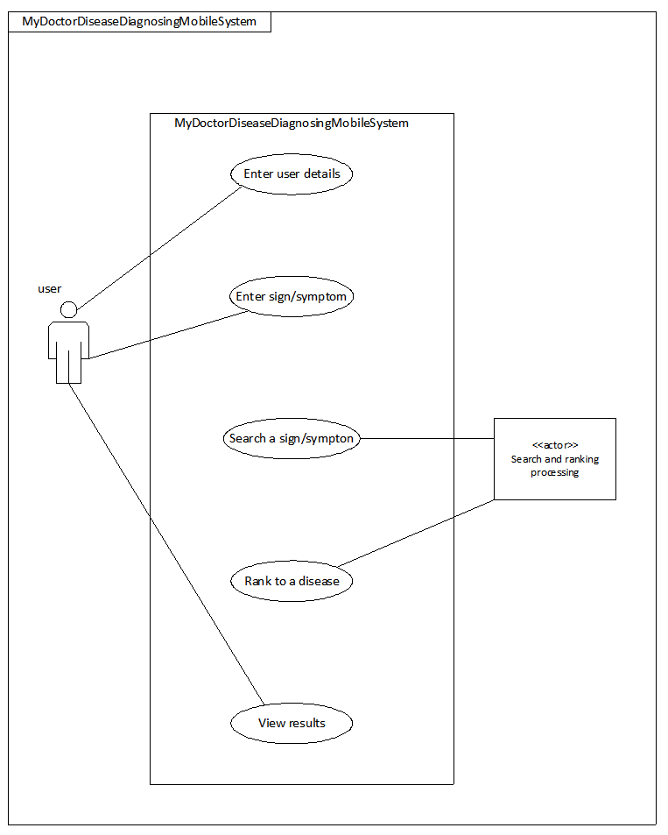

Appendix C: To Be Determined List

All features of my doctor, disease diagnosing mobile system have been explained in detail and so at the moment, the TBD list has no additional information.